**HOWARD**ENTERPRISE

KIOSK**CHECKLIST**

*Packet must be completed in its entirety prior to receipt of PO and lead time beginning.*

COMPANY: CUSTOMER #: QUOTE #:

**SECTION 1: INITIAL QUOTE INFORMATION**

Identify your selections by circling the option or filling in the blank with exact quantities and detailed information.

#### UNIT TYPE:

HOWARD ONE INDOOR OUTDOOR: DRIVE-UP WALK-UP WALL MOUNT THRU WALL

QUANTITY: HOWARD TWO INDOOR ONLY

QUANTITY: ALL UNITS:

QUANTITY:

Existing unit’s dimensions will fit location? Y / N *See attached drawings for reference.*

Front access door hinged on the left or right?

#### IF HOWARD ONE OUTDOOR UNIT: WALL MOUNT:

What is the wall material?

Distance from existing wall to curb? Power will be run to unit from: ground wall other:

What is the curb height? What is the curb material?

#### THRU-WALL:

What is the thickness of the wall? What is the wall composition?

*NOTE: Customer is responsible for having a contractor remove wall section and evaluate stability based on applicable building codes.*

#### DRIVE-UP:

Existing structure modifications?

Has the site been reviewed by local code personnel to see if the unit can support the installation? Y / N

Height restrictions? Power will be run to unit from: ground wall other:

If applicable, what is the distance from existing wall to curb? What is the curb height and material?

#### HARDWARE COMPONENTS:

Please select each of the following hardware components that you would like in your unit:

Card Reader Receipt Printer

Bar Code Reader Bill Acceptor

Check Reader

#### PROCESSORS: CREDIT CARD PROCESSOR: VANTIV FREEDOM PAY ACCUFUND OTHER:

CHECK PROCESSOR: SAGE OTHER:

CREDIT CARD TYPES:

WARRANTY:

WARRANTY OPTIONS

1-Year Limited Hardware Warranty, Parts Only

2-Year Limited Hardware Warranty, Parts Only

3-Year Limited Hardware Warranty, Parts Only

4-Year Limited Hardware Warranty, Parts Only

5-Year Limited Hardware Warranty, Parts Only

1-Year Limited Hardware Warranty, Parts Only, with 1-Year Next Business Day

2-Year Limited Hardware Warranty, Parts Only, with 2-Year Next Business Day

3-Year Limited Hardware Warranty, Parts Only, with 3-Year Next Business Day

4-Year Limited Hardware Warranty, Parts Only, with 4-Year Next Business Day

5-Year Limited Hardware Warranty, Parts Only, with 5-Year Next Business Day

*NOTE: See full warranty agreement for conditions and details.*

#### SERVICE AND MAINTENANCE OPTION:

Quarterly Service and Maintenance *will include general cleaning of components and unit, testing of hardware, and power supplies and cable management tracks. Check the option you prefer.*

1 Year 2 Year 3 Year 4 Year 5 Year

#### MINIMUM KIOSK REQUIREMENTS:

POWER AND CONNECTIVITY:

* At least one 15 amp 120V AC isolated power source per kiosk.
* A certified electrician must complete the wiring of power to the unit.
* A dedicated network connection.

OUTDOOR UNITS:

* A canopy or structural equivalent protecting the unit from the elements.
* A minimum 2 inch thick concrete pad.
* Unit must be mounted to the concrete pad.
* Suggested that customer review and install protective barriers for the unit taking into consideration placement relative to access doors.
* See attached drawings for reference.

**INTERNAL USE ONLY** SITE PICTURES EMAIL DATE:

APPROVAL FROM INSTALLATION ENGINEERING

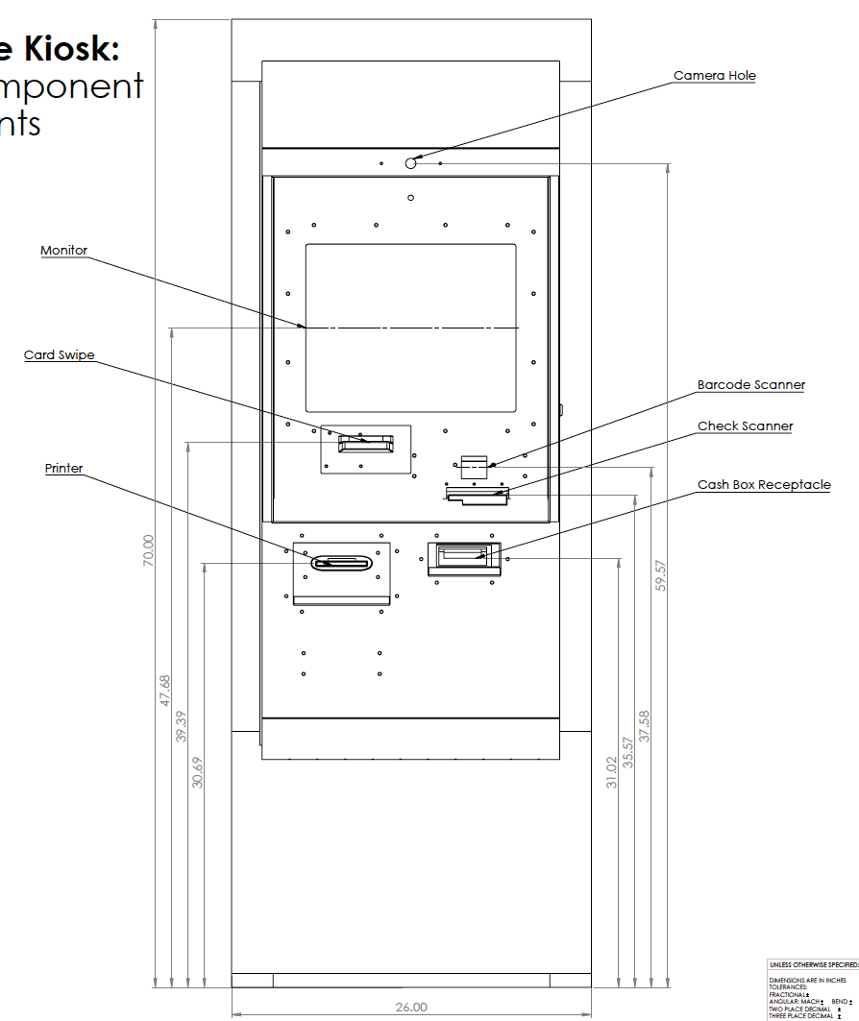

**FRONT VIEW WITH COMPONENT HEIGHTS**

**RIGHT SIDE VIEW**

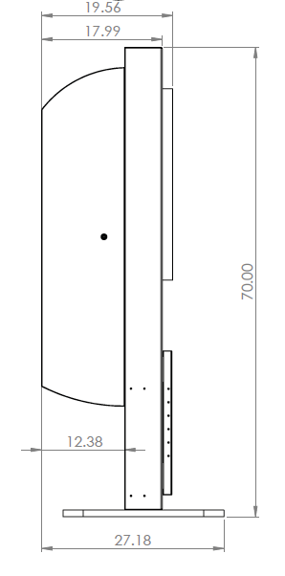

**REAR VIEW**

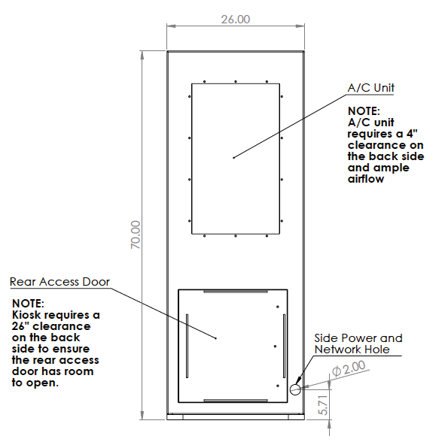**\*OPTIONAL POWER & NETWORK CONNECTIVITY LOCATION**

### TOP VIEW OF BASE PLATE

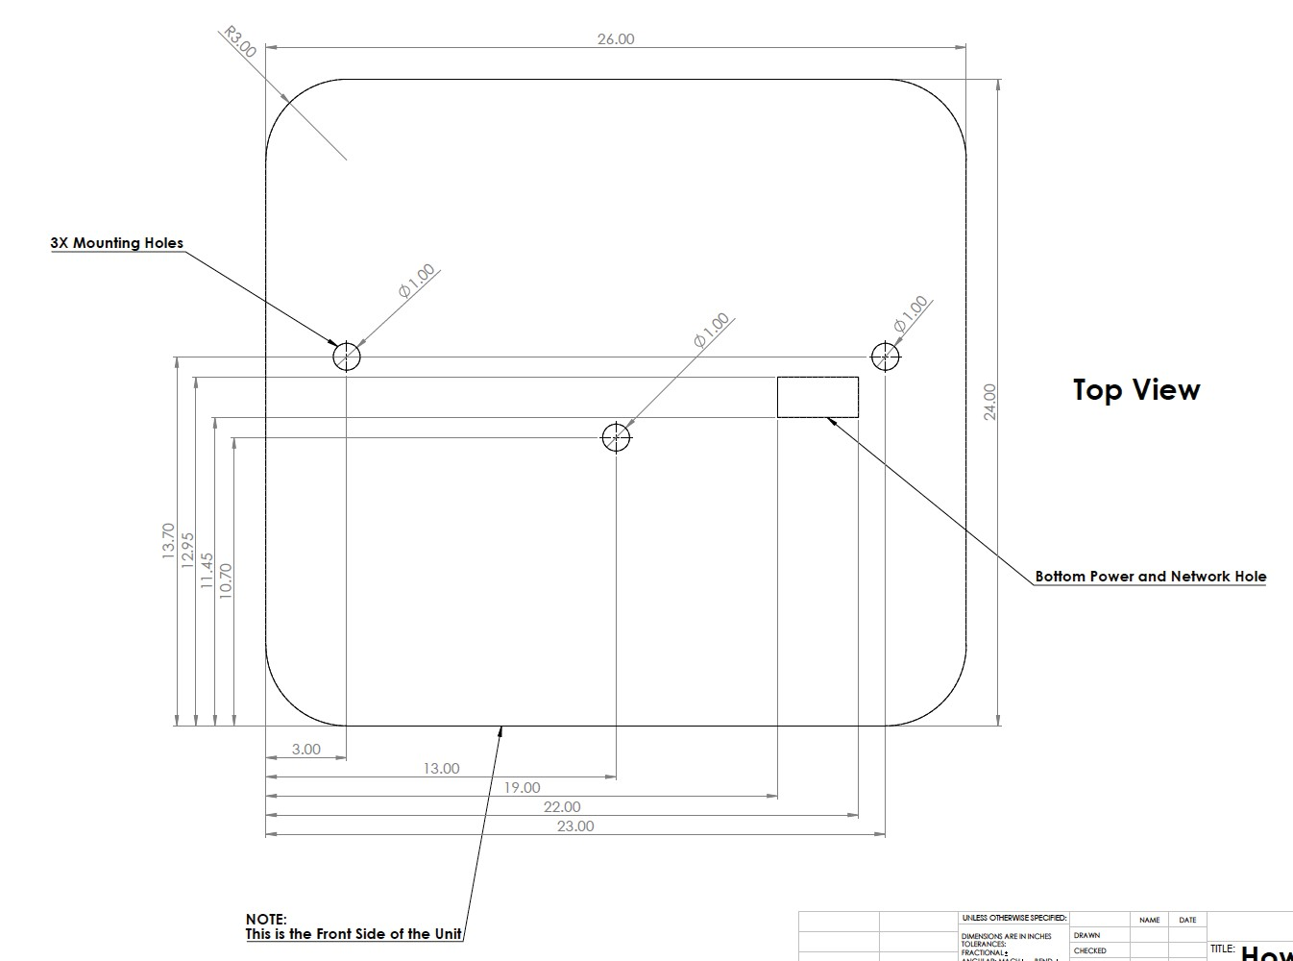

**\* STANDARD POWER & NETWORK CONNECTION LOCATION**

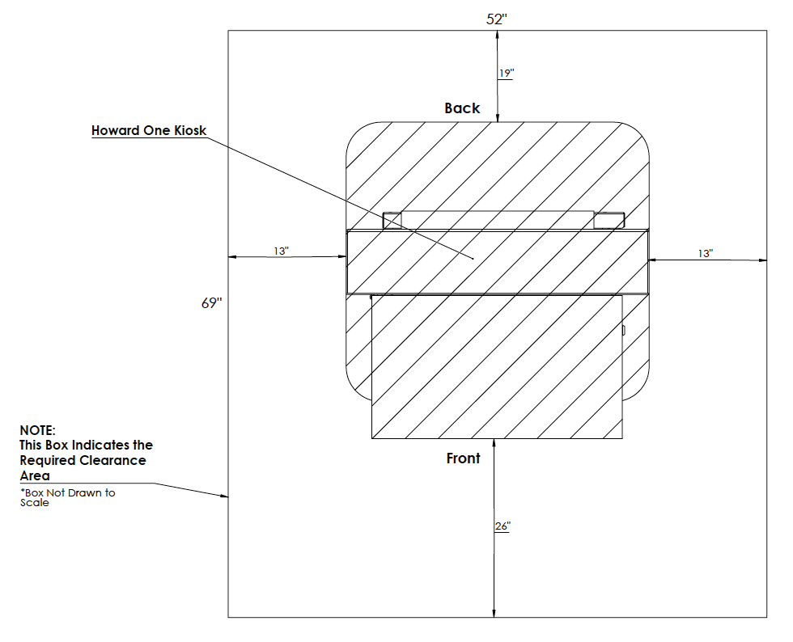**UNIT CLEARANCE REQUIREMENTS**

*NOTE: Clearance area could be decreased based on your location and specific modifications to your unit.*

**HOWARD**ENTERPRISE

KIOSK**CHECKLIST**

*Packet must be completed in its entirety prior to receipt of PO and leadtime beginning.*

COMPANY: CUSTOMER #: QUOTE #:

**SECTION 2: SITE PLANNING**

PRE-REQUIREMENTS:

Site Survey Date: Time: am/pm

Site Contact Information - Name: Phone #:

Address of Kiosk Location: Measurements of Kiosk Location:

Pad Length: Pad Width: Pad Height: Height to above canopy:

#### SITE ACCESSIBILITY, CONDITIONS AND POTENTIAL:

The following section will detail unit dimensions and list requirements for an optimally performing kiosk.



**FRONT VIEW WITH COMPONENT HEIGHTS**

### RIGHT SIDE VIEW



### REAR VIEW

**\*OPTIONAL POWER & NETWORK CONNECTIVITY LOCATION**

### TOP VIEW OF BASE PLATE



**\* STANDARD POWER & NETWORK CONNECTION LOCATION**

**UNIT CLEARANCE REQUIREMENTS**

*NOTE: Clearance area could be decreased based on your location and specific modifications to your unit.*

Number of kiosks being installed:

Is a loading dock or receiving area present? Is a lift gate needed or required?

Is dock height standard of 4 feet? Is a pallet jack available?

Is a dolly available? (500 lb min weight limit)

How suitable is the ground floor for transport of unit (~300lbs)? Has the installation area been cleared?

Is any special facility construction required? Y / N

If yes, explain: Is a trash container available for disposal of pallet and cardboard?

Does the contact agree with the final location?

Does local management agree with the final location? Is the final location in a well-lit or user-friendly area? Will the kiosk be in proximity to a heating vent?

If yes, what changes will the customer make? Outdoor units must be located under a canopy or similar structure to protect the unit from the elements.

How is the unit protected from the elements? Will there be direct AM sunlight on the monitor? Will there be direct PM sunlight on the monitor?

Will the final location allow 26” of clearance for the rear doors of the kiosk to open?

Is securing or mounting the kiosk to the floor a requirement? Will the kiosk be mounted to the wall?

Y / N

What type of wall?

If on the wall, are the studs 16” centers?

Additional notes on the location:

Will security clearance be required for this installation?:

Will documentation need to be provided in order to gain access to the site? Who is to be given the keys after installation is complete?

#### POWER AND CONNECTIVITY PER KIOSK:

Are power sources and cabling installed and functioning? Y / N

Is there a dedicated and isolated power source for the kiosk at the final location? Y / N

Is at least one terminated 15 amp 120V AC power outlet per kiosk available? Are the grounds tested?

Y / N

Power is supplied to the unit from the bottom or the rear. Your selection as to where you want power supplied

will also be where the network is connected. See kiosk dimensions for locations. Circle the supply you prefer: BOTTOM REAR

*Note: A certified electrician must complete the wiring of the power to the kiosk, unless the customer approves a standard power plug exiting the back of the unit.*

Is a dedicated network connection currently available and active? If not, when?

How many network outlets are currently available? How far is the network port from the kiosk location?

Is there sufficient data capacity on the existing network hardware for this install? Is the internet accessible, and is the router configured for the kiosk network card?

Specifics: Static IP: DHCP: Wireless:

Any additional information about the network:

Site survey has been completed and confirmed:

Name: Date:

**HOWARD**ENTERPRISE

KIOSK**CHECKLIST**

*Packet must be completed in its entirety prior to receipt of PO and lead time beginning.*

COMPANY: CUSTOMER #: QUOTE #:

**SECTION 3: DESIGN OPTIONS**

LOGO PLACEMENT: SELECT BRANDING LOCATION

Select by checking the location(s) of your brand’s logo and/or lettering given the following four options:

# A

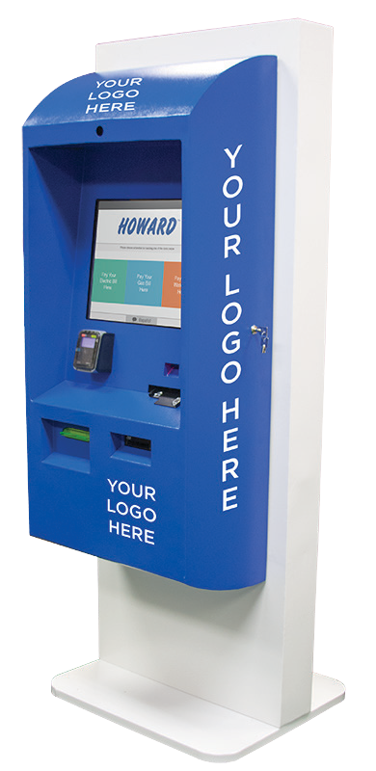

Max size is 17.5in x 12in

# B

Right Side Door

Max size is 40in x 8in

# C

Max size is 8in x 8in

# D

Left Side Door

Max size is 40in x 8in

Your logo will be sized to best fit the available space.

#### COLOR: SELECT BASE AND FRONT COLOR

Standard color options for the unit are listed below. You may choose up to two of our standard, powder- coat colors at no additional cost. Custom colors

and designs will result in additional expense and lead time.

#### BASE COLOR

FRONT COLOR

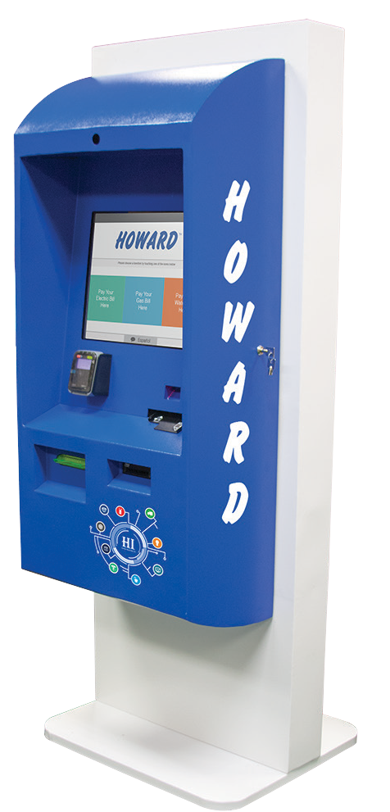

##### BASE COLOR: FRONT COLOR:

CUSTOM COLORS: Base color: Front color:

*\*Custom colors will result in additional expense and lead time.*

##### PTWH0013

Snow White

##### PTMH0039

Viridian Green

##### PTGH0014

Forest Green

##### PTRH0007

Candy Red

##### PTDH0011

Khaki

##### PTMH0035

Brass

##### PTMH0038

Midnight Blue

##### PTLH0016

Royal Blue

##### PTAH0088

Grey

##### PTAH0084

Silver

##### PTBH0004

Chocolate

##### PTAH0089

Raven Black

**CUSTOMER MOCKUP APPROVAL**

##### BASE COLOR: FRONT COLOR: LOGO PLACEMENT:

INSERT MOCK-UP

A Top of Door

Inches from left:

Inches from right: Inches from top: Inches from bottom:

Right Side Door

B

Inches from left: Inches from right: Inches from top: Inches from bottom:

Bottom of Door

C

Inches from left: Inches from right: Inches from top: Inches from bottom:

D Left Side Door

Inches from left:

Inches from right: Inches from top: Inches from bottom:

Please initial the following statements acknowledging you have agreed to comply with the requirements for a successful kiosk purchase and installation.

The customer is responsible for running a dedicated, isolated, 15 amp 120V AC minimum power source for the kiosk location.

The customer is responsible for running a standard, dedicated network using an RJ45 connector to the kiosk location.

The pedestal mount is the standard mounting option. For other options, please contact your sales representative.

If through-the-wall unit is selected, the customer is responsible for hiring a contractor to remove the wall section and to confirm the structural stability for the kiosk being installed. Also, the contractor must verify the safety of the installation per applicable building codes.

The customer will email images of the site location, including the power and network outlet locations t[o KioskTeam@howard.com](mailto:KioskTeam@howard.com)

The customer will email high quality logo images t[o KioskTeam@howard.com.](mailto:KioskTeam@howard.com)

The customer has approved the final mockup of the unit with the logos and colors selected, and has emailed the selection t[o KioskTeam@howard.com.](mailto:KioskTeam@howard.com)

Signing below indicates that the customer has reviewed the checklist and has complied with all of the requirements for kiosk installation. It also indicates that the next step will be to submit a purchase order. Upon receipt of PO, the standard time frame for completing your unit is 10 weeks, unless custom or non-standard options are selected or requested. Any modifications to your orders after receipt of the kiosk checklist could result in additional lead time.

Customer Signature

Howard Sales

Date

Date

***FOR INTERNAL USE ONLY***

COMPANY: CUSTOMER #: ORDER #: CONTRACTS SENT TO CUSTOMER:

SAGE (CHECKS)

PO #:

DATE SENT TO CUSTOMER: DATE RECEIVED FROM CUSTOMER:

VANTIV (CREDIT CARDS)

DATE SENT TO CUSTOMER: DATE RECEIVED FROM CUSTOMER:

FREEDOM PAY (CREDIT CARDS)

DATE SENT TO CUSTOMER: DATE RECEIVED FROM CUSTOMER:

ACCUFUND (CREDIT CARDS)

DATE SENT TO CUSTOMER: DATE RECEIVED FROM CUSTOMER:

WAS AN AGENT INVOLVED? Y / N

NAME OF AGENT: