Please use the list of literature below to order printed materials.

Overview Brochures

 |  | Howard Med Linecard | Linecard | 1 (front and back) | 202404V48 | https://media.howard.com/literature/Technology/Howard/current/medical/linecards/med_linecard.pdf | 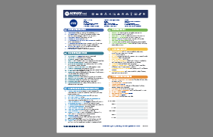
 |  | Healthcare Solutions Portfolio | Overview Brochure | 28 | 202211V2 | https://media.howard.com/docs/downloads/2022_hmed_portfolio.pdf | 
 |  | Howard Medical Overview | Overview Brochure | 12 | 202301V7 | http://media.howard.com/literature/technology/howard/current/medical/medical_overviews/v6_howard_med_overview.pdf | 
 |  | 2023 Product Lineup  (HIMMS Expanded Linecard) | Tradeshow Brochure | 8 | 202303V5 | https://media.howard.com/docs/downloads/2023_Extended%20Linecard.pdf | 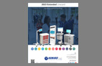

Cart Brochures

 |  | HI-Rise | HI-View | Overview Brochure | 4 | 202110V1 | http://media.howard.com/literature/Technology/Howard/current/medical/Cart_Brochures/HI-View%20HI-Rise%20EXT/Product%20Overview%20HI-Rise%20%20HI-View_solutions.pdf | 
 |  | Reach Your Patients With Telehealth | Sheet | 1 (front and back) | 202004V2 | http://media.howard.com/literature/technology/howard/current/medical/single_sheets/telehealth/Reach_Your_Patients_With_Telehealth_howardbranded.pdf | 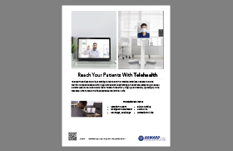
 |  | HI-Care | Cart Brochure | 8 | 202204V8 | https://media.howard.com/docs/downloads/HI-Care%20Brochure%202023.pdf | 
 |  | HI-Core | Cart Brochure | 8 | 202204V9 | https://media.howard.com/docs/downloads/HI-Core%20Brochure_2023.pdf | 
 |  | HI-Swift | Cart Brochure | 8 | 202306V2 | https://media.howard.com/docs/downloads/HI-Swift_Brochure_2023.pdf | 
 |  | HI-Paradigm | Cart Brochure | 8 | 202204V8 | http://media.howard.com/literature/technology/howard/current/medical/Cart_Brochures/HI-Paradigm/HI-Paradigm%20Brochure%202018%2011.2.18.pdf | 
 |  | HI-Pinnacle E | Cart Brochure | 8 | 202306V1 | https://media.howard.com/docs/downloads/hi-pinnacle_brochure.pdf | 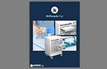
 |  | Fixed Solutions | Arms and Cabinets Brochure | 12 | 201806V3 | http://media.howard.com/literature/technology/howard/current/medical/Cart_Brochures/fixed_solutions/Fixed_Solutions_Brochure.pdf | 
 |  | HI-Focus Procedure Cart One Sheet | Cart One Sheet | 1 (Front and Back) | 202212V1 | https://media.howard.com/docs/downloads/HI-Focus%20One%20Sheet.pdf | 
 |  | Pinnacle 30 One Sheet | Cart One Sheet | 1 (Front and Back) | 202305V1 | https://media.howard.com/docs/downloads/Pinnacle%20One-Sheet_2023.pdf | 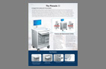
 |  | Pinnacle 30 Accessories | Cart One Sheet | 1 (Front and Back) | 202305V1 | https://media.howard.com/docs/downloads/P30_acc_sheet.pdf | 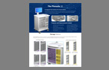
 |  | Transfer Cart | Cart Brochure | 4 | 202309V1 | http://media.howard.com/site/HowardMedical/docs/pdfs/E-Series/med_hub_and_transfer_cart_brochure_8-11-17.pdf | 

Solution Category Brochures

 |  | Computing Solutions | Solutions Brochure | 4 | 202106V3 | https://media.howard.com/literature/Technology/Howard/current/medical/medical_solutions/a_computing_solutions/computing_solutions.pdf | 
 |  | Mobile Device Charging Solutions | Solutions Brochure | 4 | 202106V5 | https://media.howard.com/literature/Technology/Howard/current/medical/medical_solutions/a_computing_solutions/charging_solutions.pdf | 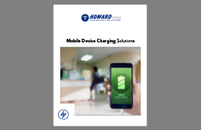
 |  | Audiovisual Solutions | Solutions Brochure | 4 | 202106V3 | https://media.howard.com/literature/Technology/Howard/current/medical/medical_solutions/b_audiovisual_solutions/audiovisual_solutions.pdf | 
 |  | Networking Infrastructure Solutions | Solutions Brochure | 4 | 202106V3 | https://media.howard.com/literature/Technology/Howard/current/medical/medical_solutions/c_networking_infrastructure_solutions/networking_infrastructure_solutions.pdf | 
 |  | Virtualization Solutions | Solutions Brochure | 4 | 202106V4 | https://media.howard.com/literature/Technology/Howard/current/medical/medical_solutions/d_virtualization/virtualization_solutions.pdf | 
 |  | Physical Security Solutions | Solutions Brochure | 4 | 202107V5 | https://media.howard.com/literature/Technology/Howard/current/medical/medical_solutions/e_physical_security_solutions/physical_security_solutions.pdf | 
 |  | Kiosk Solutions | Solutions Brochure | 8 | 202107V10 | https://media.howard.com/literature/Technology/Howard/current/medical/medical_solutions/f_kiosks_and_digital_signage/kiosk/kiosk_solutions_expanded.pdf | 
 |  | Digital Signage Solutions | Solutions Brochure | 4 | 202106V3 | https://media.howard.com/literature/Technology/Howard/current/medical/medical_solutions/f_kiosks_and_digital_signage/digital_signage/digital_signage_solutions.pdf | 
 |  | Software Solutions | Solutions Brochure | 4 | 202106V3 | https://media.howard.com/literature/Technology/Howard/current/medical/medical_solutions/g_software_solutions/software_solutions.pdf | 
 |  | Professional Services Solutions | Solutions Brochure | 4 | 202106V1 | https://media.howard.com/literature/Technology/Howard/current/medical/medical_solutions/h_professional_services/professional_services_solutions.pdf | 
 |  | E-Commerce & Accessories Solutions | Solutions Brochure | 4 | 202106V3 | http://media.howard.com/literature/Technology/Howard/current/medical/medical_solutions/i_e-commerce_and_accessories/e_commerce_and_accessories_solutions.pdf | 
 |  | Point-of-Care Solutions | Solutions Brochure | 4 | 202204V8 | http://media.howard.com/literature/Technology/Howard/current/medical/medical_solutions/j_point-of-care_solutions_and_technology/point_of_care_solutions.pdf | 
 |  | Point-of-Care Technology Solutions | Solutions Brochure | 4 | 202103V4 | http://media.howard.com/literature/Technology/Howard/current/medical/medical_solutions/j_point-of-care_solutions_and_technology/technology_poc_solutions.pdf | 
 |  | Telehealth Solutions | Solutions Brochure | 4 | 202106V8 | http://media.howard.com/literature/Technology/Howard/current/medical/medical_solutions/k_telehealth_solutions/telehealth_solutions_overview.pdf | 
 |  | Patient Experience Solutions | Solutions Brochure | 4 | 202106V4 | http://media.howard.com/literature/technology/howard/current/medical/medical_solutions/patient_experience_solutions/patient_experience_solutions.pdf | 
 |  | Virtual Visitor Solutions | Overview  Brochure | 4 | 201909V1 | http://media.howard.com/literature/technology/howard/current/medical/medical_overviews/virtual_visitor_solutions.pdf | 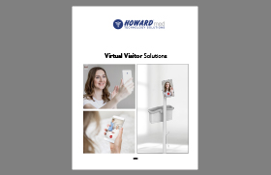
 |  | Patient Check In Solutions | Overview  Brochure | 8 | 2020010V1 | http://media.howard.com/literature/technology/howard/current/medical/medical_overviews/Patient_Check-In_.pdf | 
 |  | Infection Control Solutions | Brochure | 8 | 202010V2 | https://media.howard.com/docs/downloads/Infection_Control_Solutions.pdf | 

One Pagers

 |  | Generic Security Solutions | Sheet | 1(Front and Back) |  | https://media.howard.com/docs/downloads/MED_physical_security_Generic_2023.pdf | 
 |  | Nursing Solutions | Sheet | 1 (Front and Back) | 202204V8 | https://media.howard.com/docs/downloads/Nursing%20One%20Sheet.pdf | 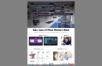
 |  | IT’s Best Friend | Sheet | 1 (Front and Back) |  | https://media.howard.com/docs/downloads/IT_Best_Friend.pdf | 
 |  | Phlebotomy Soltuions | Sheet | 1 (Front and Back) | 202305V1 | https://media.howard.com/docs/downloads/Phlebotomy%20One%20Sheet.pdf | 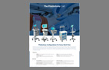
 |  | Swiss Army Knife | Sheet | 1 (front and back) |  | https://media.howard.com/docs/downloads/Howard_Swiss.pdf | 
 |  | Cyber Security | Sheet | 1 (front and back) |  | https://media.howard.com/docs/downloads/Cyber_Security_one%20sheet.pdf | 

Premier One Sheets
For Premier contract customers only. Contact Wes Craddock for more information.
 |  | Premier Security Solutions | Sheet | 1 (Front and Back) |  | https://media.howard.com/docs/downloads/Premier_physical_security_one_pager_MED.pdf
 |  | Premier Carts | Sheet | 1 (Front and Back) |  | https://media.howard.com/docs/downloads/MED_Premiere_Cart_Contract.pdf | 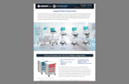
 |  | Premier PX & TV Solutions | Sheet | 1 (Front and Back) |  | https://media.howard.com/docs/downloads/MED_Premiere_Tv_Oneview_Contract.pdf | 
 |  | Premier Combined Solutions | Sheet | 1 (Front and Back) |  | https://media.howard.com/docs/downloads/Premier_Contract_Combined.pdf | 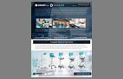

Miscellaneous

 |  | Mobile Showcase | Sheet | 1 (front and back) | 202211V1 | https://media.howard.com/docs/downloads/med_Mobile_showcase.pdf | 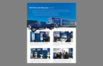
 |  | Long Term Care | Brochure | 4 | 202302V1 | https://media.howard.com/docs/downloads/Long-Term_Care_One_sheet.pdf | 
 |  | VA Solutions Brochure | Brochure | 8 | 202204V7 | https://media.howard.com/docs/downloads/VA_Brochure_2023.pdf | 
 |  | LED Healthcare Lighting Solutions | Sheet | 1 (front and back) | 202008V1 | http://media.howard.com/literature/technology/howard/current/medical/single_sheets/lighting/med_healthcare_lighting_solutions.pdf | 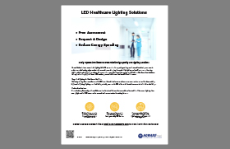
 |  | Career Opportunities To Join Our Team | Career Opportunities Sheet | 1 (front and back) | 202002V2 | http://media.howard.com/literature/Technology/Howard/current/medical/medical_overviews/medical_career_opportunities.pdf | 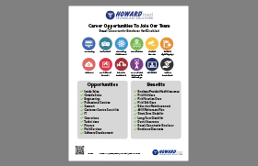
 |  | Howard Medical Approved Products | APP Customer Wishlist | 1 (front and back) | 201903V1 | https://media.howard.com/docs/downloads/Howard%20Medical%20Approved%20Products%20Page.v1.pdf | 