
Date 00/00/00
OPP# 001234

Client Name Here

Project Name Here

Table of Contents

Table of Contents 2
Executive Summary 3
Scope of Work 3
System Highlights 3
Technical Services 3
Costs Outline 3
Time Estimates 3
Project Overview 4
The Background 4
The Objective 4
The Opportunity 4
The Requirements 4
The Solution 4
Our Proposal 5
Assumptions 5
Project Deliverables 5
Owner Furnished Equipment 5
Pricing 6
HTS Quote 6
Who We Are 7
Our Qualifications 7
Approval and Authority to Proceed 8
Appendix 8
Stakeholders Contact List 8
Survey Notes 8
Technical Drawings 8

Executive Summary

Scope of Work
This project shall consist of the design, delivery, programming, and installation of 10 auditoriums at ABC University – Main Campus.

System Highlights
(Sample List)
- Epson Projector
- Epson Whiteboard
- Spectrum Podium
- Crestron Digital Media Presentation System
- Crestron 7” Tabletop Touch Screen
- HDMI/ USB Wallplate

Technical Services
- System Design
- Project Documentation
- Crestron Programming
- Project Management
- System Fabrication
- Installation and Commissioning

Costs Outline
Deliverable | Cost
Equipment | $110,000
Programming | $6,500
Installation | $18,500
Other | $3,500
Total Cost | $138,500

Time Estimates
- Order to delivery – 4 weeks
- System Fabrication – 1 week
- Installation Phase – 2 weeks
- Commissioning Phase –1 week
- Estimated Time from Order to Completion = 8 Weeks

Project Overview
Provide a summary of the reason for the proposal, and how you can best support the client’s needs. You can expand on this summary throughout the rest of the proposal.

The Background
[Describe how this project came about, who is involved, and the client’s reason for moving forward.]

The Objective
Include a purpose statement that covers the problem and the key theme around our solution. Restate the client’s needs as determined by reading their RFP or your previous interview process.
Need #1: Briefly restate the primary need of customer for this project
Need #2: Briefly restate the secondary need of customer for this project
Need #3: Briefly restate the additional needs of customer for this project

The Opportunity
Include major points and identify the opportunity. Restate the client’s project goals you identified previously (such as via RFP, interview, etc.)
Goal #1: Briefly state the primary goal for this project
Goal #2: Briefly state the secondary goal for this project
Goal #3: Briefly state the other goals for this project

The Requirements
The new system must include the following:
Requirement #1: Briefly state the primary requirement for this project
Requirement #2: Briefly state the secondary requirement for this project
Requirement #3: Briefly state the other requirements for this project

The Solution
Summarize what you’re proposing to do and how you’re going to meet the goals. You’ll be able to expand on the details within the ‘Our Proposal’ section. Include recommendations that lead to your proposed solution.
Recommendation #1: Recommendation # 1 statement
Recommendation #2: Recommendation # 2 statement
Recommendation #3: Recommendation # 3 statement

Our Proposal
Provide background information, including a brief background on your company and your understanding of the client’s needs and specific issues to be addressed. You may also choose to include the results of any related research, project history, and additional factors that impact the client’s needs, such as socio-economic trends or impending regulations.

Show your understanding of the benefits the client can expect. For example, describe the risks--what might be lost--if appropriate action is not taken and compare this to the benefits they can achieve with a positive course of action. If applicable, identify potential areas of concern for the client and how you can address them. Such items may be fundamental issues that appear trivial but are often overlooked by competing proposals. Describe how your capabilities and proposed solution align with the client’s goals for the project, including how your qualifications can uniquely address the current opportunity.

Assumptions
List any assumptions made in the creation of this proposal that could affect the price should they be incorrect.

Project Deliverables
Following is a complete list of all project deliverables:
Deliverable | Description
Deliverable #1 | Brief Description
Deliverable #2 | Brief Description
Deliverable #3 | Brief Description

Owner Furnished Equipment
The following materials are to be supplied by Client Name Here for this project. For Your Company to meet project milestones, this material must be supplied on schedule. The due dates included in the following table represent our best guess based on current proposed project dates:$$
Equipment to be supplied by Client Name Here | Due Date*
Item #1 | 00/00/00
Item #2 | 00/00/00
Item #3 | 00/00/00

*We cannot be responsible for cost overruns caused by client’s failure to deliver materials by agreed-upon due dates.

Pricing
The following quote details the pricing for the equipment and services outlined in this proposal and is valid for 30 days.

HTS Quote
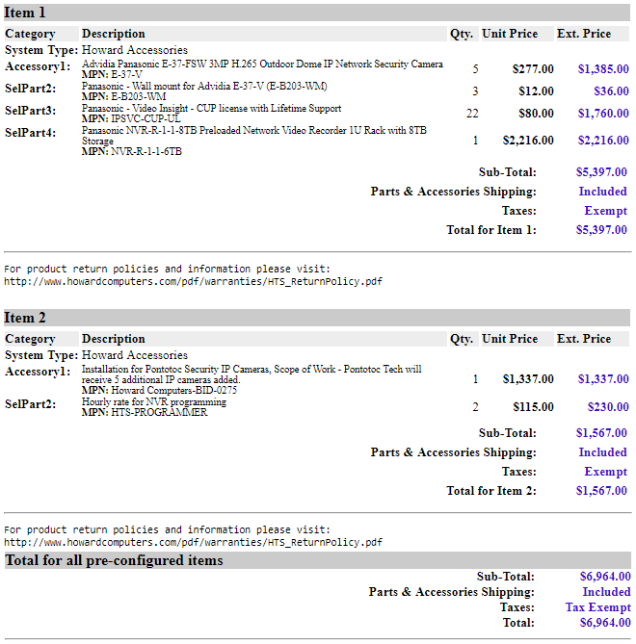
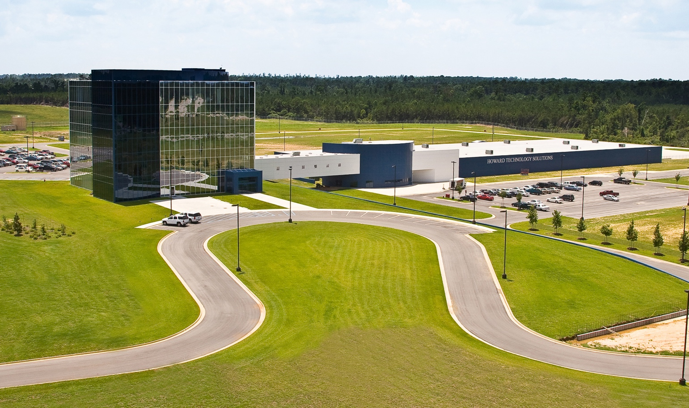

Who We Are
In 1968, a young Billy W. Howard, Sr. left his successful career at General Electric to return to his native Mississippi and create his own company, Howard Industries. Over the next five decades and with the assistance of his wife, Linda, Howard Industries has grown to become a billion dollar company consisting of four separate divisions plus a wholly-owned subsidiary, Howard Transportation.
Howard Technology Solutions, from its home at the Howard Technology Park in Ellisville, MS, brings to market cutting-edge technology—high quality, reliable, and affordable. From our own Howard manufactured products, such as desktops, notebooks, servers, kiosks, and medical carts to partner products from other leading technology innovators, such as Lenovo, HP, and Microsoft, you can be sure when you buy from Howard that you are getting the most for your technology dollars.

Our Qualifications
From projectors, document cameras, and sound amplification systems to interactive technologies, control systems, and presentation carts, Howard has what it takes to create an audiovisual-rich environment. We offer a wide range of design and installation services that include consultations, CAD drawings, bid specifications, and integration—projects of any size, performed by experienced, certified engineers who specialize in industry standards and programming.
Your Company is continually proven to be an industry leader for high quality/guaranteed product/service in the following ways:

Describe what sets your company apart from your competition (your unique selling proposition).

Unique point #1
Unique point #2
Unique point #3

Describe the Strengths of your company, focusing on specializations that are most relevant for this project. As appropriate, include additional strengths of your unique selling proposition that provide benefits the customer may not have articulated.

Identify qualifications that support your ability to address client needs for the project.

Provide information that shows how you can meet the required schedule, such as staffing/ subcontractors and percentage of time devoted to the project.

Approval and Authority to Proceed
We approve the project proposal as described above and request Howard Technology Solutions proceed with the design and ordering.

Name | Title | Date

Approved By |  |  | Date |  | Approved By |  |  | Date

Approved By |  |  | Date |  | Approved By |  |  | Date

Appendix

Stakeholders Contact List
Name | Organization | Role | Phone | Email
Colin Entrekin | Howard | PM | 555.555.5555 | centrekin@howard.com

Survey Notes
(Insert or Link Here)
Project Information
Project Information Walkthrough Done By:
Name Here
School Name:  Name Here | Campus Name:  Name Here | Building name:  Name Here | Did you walk  every room?  Yes/No
Project or Room Name:  Board Room | Walk Through Date:  9/13/2018
Room Dimensions:  00 L x 00 W x 00 H | Wall Type:  Block | Ceiling Type:  Drop | OPP Number:  OPP-001234
Target Install Date:  ASAP | Target Budget:  $10,000 | Delivery Doc:  Yes/No | Plenum Space:  Yes/No
Project Overview: Write a simple scope of the project and how the system needs to function. This will be used in the SOW.
Answer Here
Suggested Equipment: Provide any make and model or standards discussed during the walkthrough.
Answer Here
OFE Equipment: Provide a list of all Equipment that will be provided by the customer.
Answer Here
Video Inputs: Provide a list of desired Input types and sources
Answer Here
Display Needs: Provide type of display, Projector with suggested brightness, Resolution and throw distance or displays with size and quantity
Answer Here
Screen: Provide all information on proposed screen, Diagonal image Size, Aspect Ratio, and mounting type
Answer Here
Audio: Speaker type, mounting, Proposed quantity and function of audio system IE; Speech reinforcement, concert, program audio etc.
Answer Here
Control System: Control system Type with control surface (7" touch panel or 10 button panel with volume knob) also list equipment that needs to be controlled
Answer Here
Programming Notes: Anything special discussed for programming? Discuss with the customer that we may need to schedule a call to discuss the programming needs
Answer Here
Network: Will be new equipment go on the school’s network or do we need to provide a switch? Does the school network able to provide POE?
Answer Here
Conduit, Floor Boxes or Raceway: Is there available conduit, existing Floor boxes, or do we need to provide raceway and wall boxes?
Answer Here
Plans/ Blueprints: Are plans available for the room or building? Can they be provided in a PDF or DWG Format?
Answer Here
Lifts: Are lifts needed, are any on site that can be used? Or do we need to provide them in the BOM. Tall ladders, do we need to provision for ladder rental?
Answer Here

Check List: Remember we want to provide enough information that a PM can read the notes and meet the customer’s expectation.
Explain that they will receive a SOW with the quote and that the SOW explains how the system will work and product placement.
Remember to offer to have a follow up call to review the quote and SOW.
Delivery Doc, this may only be necessary if they are going to be buying large equipment like whiteboards, large Screens, or just a large project.
Pictures of the room with Theta and close using phone. Room Layout
Diagram the room showing equipment locations, Use OneNote and upload to SmartSheets or Dropbox.
List existing equipment or take close-up pictures of existing equipment racks.
Was the project timeline and budget discussed?
Scope think about the scope from the installation point of view. Can a PM read it and know what’s supposed to happen during the installation?
Measure the room.
If the screen is larger than 12' we may need additional equipment or people to install. Make a note to discuss this with the customer.
Take note of cable path and equipment locations, can wire be ran from point to point.
If you have the time feel free to use OneNote to annotate on pictures for new equipment placement like speakers, wall plates, control panels and cable path.

Technical Drawings
(Insert or Link Here)

